How to create a Virtual Private Network (VPN) to Plymouth University

(with thanks to Josh Millar and Jake Hall)

You can find the University help at <https://intranet.plymouth.ac.uk/computing/remote/>

## If you are a Virgin Media customer, see the fix at the end of this document.

## Windows Users

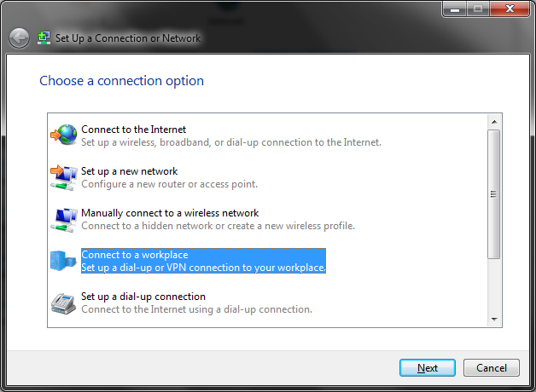First, open up your network & sharing center and select "Set up a new connection"

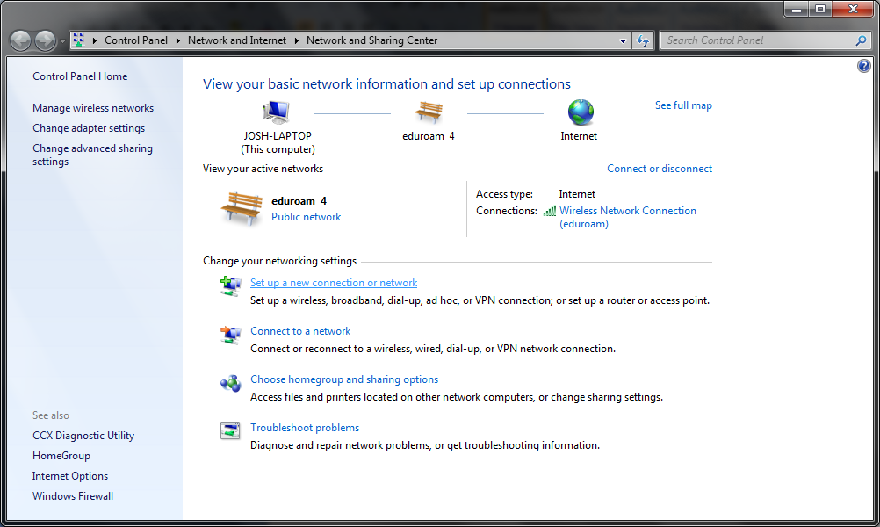Select "Connect to workplace" and click Next.

Select the first option "Use my Internet connection (VPN)".

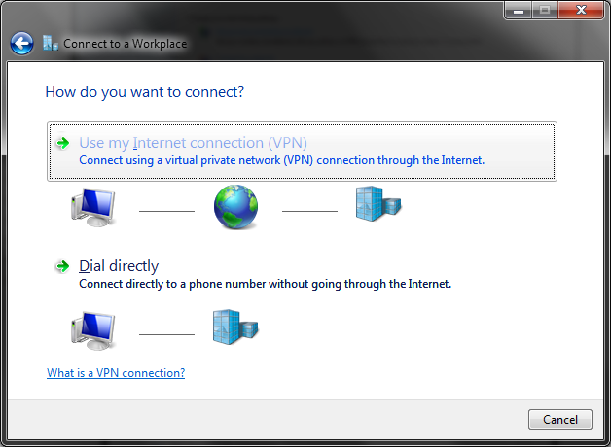

Then enter the following details and click Next:

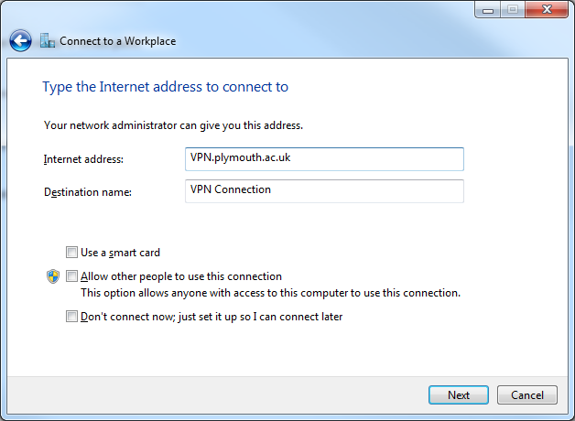

Enter your university credentials, as you would if you when logging into one of the lab machines

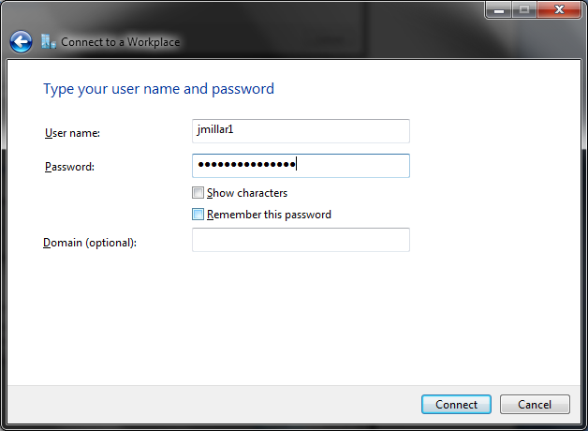

Click connect, the next process is confirming who you are and if/what you are allowed access to, you will be able to use Oracle database.

That’s it, you’re in ☺

If you experience **VPN drop outs**, try the following:

Open your VPN connection properties select Internet Protocol (TCP/IP) on the Networking tab for the properties of the VPN connection. Click Properties, and then... click Advanced.

In Advanced TCP/IP Settings, on the General tab, UNTICK the gateway on remote network check box. And for those of you interested this is called Split Tunnelling.

## Mac Users

Open Network under System Preferences

Create a new connection by clicking on the + symbol

Select VPN as the Interface and PPTP as the VPN Type and give your connection a name

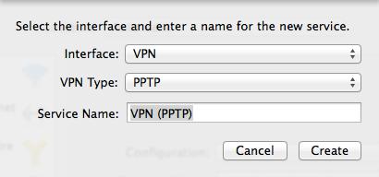

The Server Address is vpn.plymouth.ac.uk and use your University (not Oracle) username for your Account Name. You can store your password under Authentication Settings… or you can be prompted to enter it each time you want to connect.

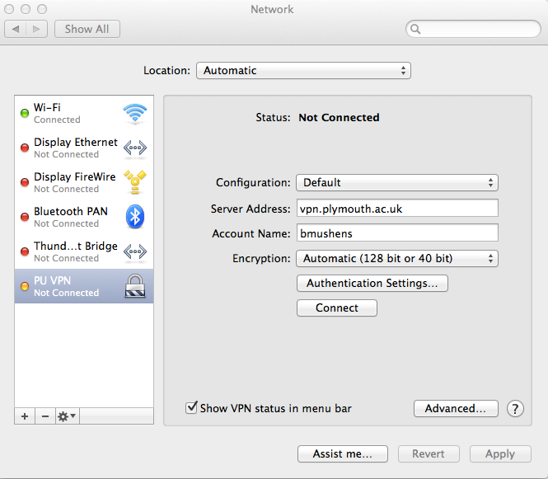

## Trouble shooting

If you are a **Virgin Media** customer, you may experience problems

I haven't tested this fix but it's worked for dozens of other students!

1. Login to Superhub, default IP 192.168.0.1

2. Enter username/password (try superuser:changeme or admin:changeme)

3. Click on Advance Settings on the bottom right of the page

4. Select Security

5. Scroll to the bottom section and tick the PPTP Pass-Through box

6. Click Apply